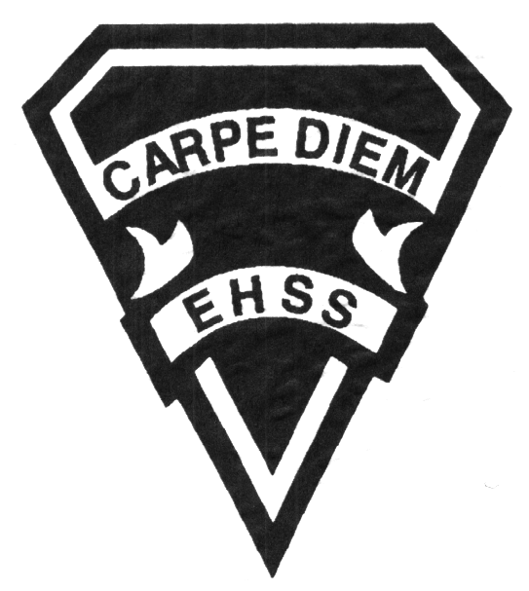

**2019/2020**

### Understanding Canadian Law

**Social Sciences Department**

## Earl Haig

SecondarySchool

# **CLU3M**

**Evaluation Profile & Outline**

**Course Description/Rationale/Overview:** This course explores elements in Canadian Law that are relevant to students as they prepare to enter the labour force. Students will learn to develop informed opinions on legal issues and defend their opinions in a variety of ways. Practical experience and active learning strategies will be emphasized.

**Class Requirements:** Students should have materials specified by the subject teacher at the beginning of the year.

The textbook for this course is Law in Action. Students will be issued this book at the beginning of the course. The replacement cost for this textbook $115.00.

**Assessment and Evaluation Strategies**

Students will also be expected to complete assessment activities of a formative nature in order to learn and to practice the specific expectations that will compose the summative evaluations. Examples of formative assessment may include homework checks, quizzes, peer assessment, presentations, reflection writing, role-play scenarios and observation.

Each unit or strand of the course will be evaluated using summative evaluations. Examples of summative evaluations are tests, case studies, interviews, reports, presentations, seminars, debates, research and other writing assignments.

**Late and/or Missed Evaluation**

##### Late Assignments*

For each assignment, the teacher will inform students of the due date. The teacher may decide to create an ultimate deadline. If an assignment is submitted after the deadline, the teacher may deduct marks up to and including the full value of the assignment.

**Missed Tests**

It is the student’s responsibility to make arrangements, ahead of time, for any tests/quizzes that are missed. If a student misses a test/quiz for an unforeseen reason such as illness, the student must bring a note signed by a parent or guardian**. Alternatively a medical certificate may be requested by the teacher.** The student must be prepared to write the test/quiz immediately upon return to school at a time determined by the teacher. Once the tests/quizzes have been evaluated and returned, students will not be able to make up a missed test - a mark of zero will be assigned.

**Subject-Specific/Department Information**

Teachers in the Social Sciences Department can be reached at (416) 395-3210, ext. 20075 or 20085. Parents wishing to meet with a teacher are requested to make an appointment with the teacher prior to coming to the school.

**Learning Skills\***

**Responsibility** – meets deadlines; takes responsibility for own behaviour

**Organization** – establishes priorities and manages time; uses information, technology and resources top complete tasks time management

**Independent Work** – follows instruction with minimal supervision; uses class time appropriately to complete tasks

**Collaboration** – accepts an equitable share of work in a group; builds healthy peer relationships; works with others to achieve group goals

**Initiative** – looks for opportunities for learning; demonstrates curiosity; approaches new tasks with a positive attitude

**Self-regulation** – sets own goals and monitors own progress; seeks assistance with needed; makes an effort with responding to challenges

###### Final Mark

The final mark for this course will be determined based upon an accumulation of marks from unit summative activities and from a final summative evaluation

**Year’s Work 70%**

This is a culmination of evaluations that have been completed throughout the year. It may include tests, presentations, research, or topic specific assignments.

**Final Summative Evaluation 30%**

This will be completed during the final six weeks of the course and may include a variety of summative activities including an exam, project presentation, seminar or a writing assignment.

**Achievement Categories and Weighting**

* **Knowledge / Understanding – 25%**

Knowledge of facts and terms; understanding of concepts, principles, guidelines and strategies; understanding of relationships among concepts.

* **Application – 25%**

Synthesizing knowledge and understanding into new and familiar contexts as well as making connections between various contexts.

* **Thinking Inquiry – 25%**

Formulating questions; planning, selecting strategies and resources; analyzing and interpreting information, and forming conclusions.

* **Communication – 25%**

Communication of information and ideas, communication for different audiences, use of various forms of communication.

*From: Ontario Ministry of Education. *Growing Success: Assessment, Evaluation, and Reporting in Ontario Schools*. Toronto: Ministry of Education, 2010, 11.



**2019/2020**

##### Understanding Canadian Law

**Social Sciences Department**

## Earl Haig

SecondarySchool

# **CLU3M**

**Evaluation Profile & Outline**

**Course Outline:**

**Unit 1: Heritage**

This unit will explore the need for laws in society and examine the historical roots of our western civilization in modern law today. Also examined will be the Constitutional history of Canadian Law and the role of Government, the courts and individuals in our legal system in interpreting and changing laws, and the categories and types of laws that we have in society.

###### Unit 2: Rights and Freedoms

This unit will be exploring the development of rights and freedoms in Canada which will include the Canadian Bill of Rights, the Canadian Charter of Rights and Freedoms, and the Human Rights Codes of Canada.

###### Unit 3: Criminal Law and Procedures

This unit will be developing a definition of crime, exploring procedures for arrest, trial, sentencing and incarceration.

###### Unit 4: Tort and Contract Law

This unit will be distinguishing between civil and criminal law, contract and civil wrongs or tort and explaining the elements and procedures involved